 | Banco Santander Internacional  1401 Brickell Avenue, Suite 1500 - Miami FL 33131

Project Implementation Plan
Change ID
IT Manager | Jose Luis Martinez Avial
Business Manager | Ted Fernandez
Requested by | Ted Fernandez
Tested by | Jinen Andee
Assigned to | Jinen Andee
Summary | ND.DEAL Release (Part2)

Special tasks

Pre-implementation tasks | N/A
During Implementation tasks | Install BCON BDER001-RLSE1329424.ND.DEAL.02  Authorization of all records
Post-implementation tasks | N/A

Description/Functional Requirements

This requirement aims to create a new revenue stream for BSI Miami with the introduction of the Non Delivery Forward business.

Justification/Requirements Analysis

Part 2 of deliverables for ND Deals
- Fiscal report
- Bloomberg
- Tax Withholding
- Pre-trade checks

Implementation

[Step 1] Installation BCON BDER001-RLSE1329424.ND.DEAL.02

[Step 2] Installation again BCON BDER001-RLSE1329424.ND.DEAL.02 (Make sure you reload the BCON)

[Step 3] Ensure the BCON has all records released and shows as “AUTHORISATION SUCCESSFUL”

[Step4]
Please add the following values in the record GLOBUS.CONST>NDFXPTC and GLOBUS.CONST>NDSDCPTC
MIAAFT28 ON MIASX4 - SANGLOBUS ROUTINE CONSTANTS INPUT
APP............... NDFXPTC
------------------------------------------------------------------------------
1. 1 CONST.NAME..... DAYS
2. 1. 1 C 730
3. 1. 1 C
1. 2 CONST.NAME..... SDCAMT
2. 2. 1 C 10000000000
3. 2. 1 C

MIAAFT28 ON MIASX4 - SANGLOBUS ROUTINE CONSTANTS INPUT
APP............... NDSDCPTC
------------------------------------------------------------------------------
1. 1 CONST.NAME..... VDAYS
2. 1. 1 C 365
3. 1. 1 C
1. 2 CONST.NAME..... SDCAMT
2. 2. 1 C 10000000000
3. 2. 1 C
4 RECORD.STATUS.....

Please modify the following values in record: FISCAL.REPORT in table GLOBUS.CONST

MIAAFT28 ON MIASX4 - SANGLOBUS ROUTINE CONSTANTS INPUT
APP............... FISCAL.REPORT
------------------------------------------------------------------------------
2.12. 1 C 620
3.12. 1 C 620 - COMMISSIONS
1.13 CONST.NAME..... TXN.MM.CAP.INT
2.13. 1 C CAP
3.13. 1 C CAP - CAPITALIZATION
1.14 CONST.NAME..... FILE.DIR
2.14. 1 C ../bnk.interface/db/loads/globus/tax
3.14. 1 C
1.15 CONST.NAME..... TXN.CODE.ND
2.15. 1 C 306
3.15. 1 C Transaction Code for ND Deal Transactions
4 RECORD.STATUS.....

STEP 4.2
A New record to be created in COB.ALL.DOWNLOAD.PARAM:
ALL.DOWNLOADS.EOD.72
DESCRIPTION....... Create NDF Withholding entries
SEQUENCE.......... 1
PROCESS.ENABLED... ENABLE
JOB.NAME CREATE.ND.WITHHOLDING.ENTRIES
MODE........... ROUTINE
GROUP.ID ALL.DOWNLOADS.EOD
CONTROL.REF RLSE1329424.1

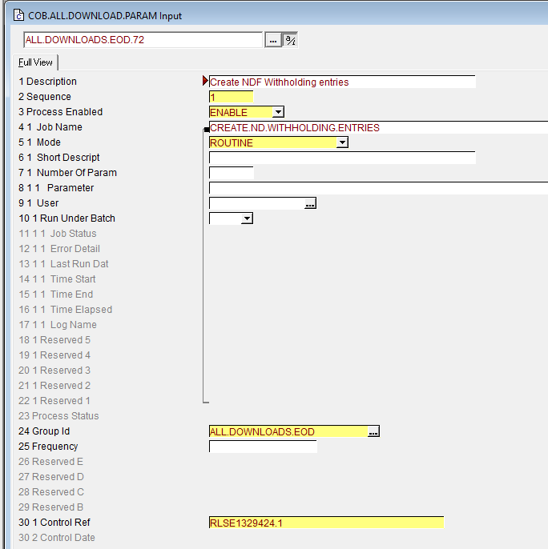
STEP 5
Modify the record 8000 from table DISPO.OFFICER to add below information:

DISPO.OFFICER.KEY. 8000
------------------------------------------------------------------------------
5. 4 NEXT.DISPO.OFF.
2. 5 OVERRIDE.ID.... SPB.FX.LINE RISK: Client & - &. No Limit Found|
3. 5 DISPO.AMOUNT...
4. 5 OVERDRAFT.AMT..
5. 5 NEXT.DISPO.OFF.
2. 6 OVERRIDE.ID.... SPB.FX.EXPIRY RISK: Client & - &. Limit Expiry f|
3. 6 DISPO.AMOUNT...
4. 6 OVERDRAFT.AMT..
5. 6 NEXT.DISPO.OFF.
2. 7 OVERRIDE.ID.... SPB.NDFX.MAX.MAT
3. 7 DISPO.AMOUNT...
4. 7 OVERDRAFT.AMT..
5. 7 NEXT.DISPO.OFF.
6 ROUTE.TO..........
7 DATE.FROM.........
8 DATE.TO...........
------------------------------------------------------------------------------
21 APR 2026 16:44:26 USER (21 NOV) MIAJANDEE-1 [8435,16PAGE 2 >>>4>>>
ACTION
AWAITING PAGE INSTRUCTIONS

STEP 6
Modify the record “ALL” from table CUSTOMER.BLCK, and add the following information:

@ID............... ALL
------------------------------------------------------------------------------
7.28 BLOCKING.DATE..
8.28 PORTFOLIO......
9.28 CHECK.RTN...... V.CHECK.LIMIT.AMT
10.28 RESERVED03.....
11.28 LOCAL.REF......
1.29 DEPARTEMENT.... PRODUCTS SUPPORT
2.29 MESSAGE........ INVALID FIN KNOWLEDGE OR PROFILE
3.29 OVERRIDE.ERROR. ERROR
4.29. 1 APPLICATION. FOREX
5.29 ACTIVE......... YES
6.29 COMMENT........
7.29 BLOCKING.DATE..
8.29 PORTFOLIO......
9.29 CHECK.RTN...... V.CHECK.PT.ERR
10.29 RESERVED03.....
11.29 LOCAL.REF......
------------------------------------------------------------------------------
21 APR 2026 16:53:43 USER (21 NOV) MIAJANDEE-1 [8435,1 PAGE 20 >>24>>>
ACTION

@ID............... ALL
------------------------------------------------------------------------------
1.30 DEPARTEMENT.... PRODUCTS SUPPORT
2.30 MESSAGE........ INVALID FIN KNOWLEDGE OR PROFILE
3.30 OVERRIDE.ERROR. ERROR
4.30. 1 APPLICATION. ND.DEAL
5.30 ACTIVE......... YES
6.30 COMMENT........
7.30 BLOCKING.DATE..
8.30 PORTFOLIO......
9.30 CHECK.RTN...... V.CHECK.PT.ERR
10.30 RESERVED03.....
11.30 LOCAL.REF......
1.31 DEPARTEMENT.... PRODUCTS SUPPORT
2.31 MESSAGE........ OVERRIDE SPB.NDFX.MAX.MAT
3.31 OVERRIDE.ERROR. OVERRIDE
4.31. 1 APPLICATION. ND.DEAL
5.31 ACTIVE......... YES
------------------------------------------------------------------------------
21 APR 2026 16:56:32 USER (21 NOV) MIAJANDEE-1 [8435,1 PAGE 21 >>24>>>

@ID............... ALL
------------------------------------------------------------------------------
6.31 COMMENT........
7.31 BLOCKING.DATE..
8.31 PORTFOLIO......
9.31 CHECK.RTN...... V.CHECK.PT.TWO
10.31 RESERVED03.....
11.31 LOCAL.REF......
1.32 DEPARTEMENT.... PRODUCTS SUPPORT
2.32 MESSAGE........ OVERRIDE SPB.NDFX.MAX.MAT
3.32 OVERRIDE.ERROR. OVERRIDE
4.32. 1 APPLICATION. FOREX
5.32 ACTIVE......... YES
6.32 COMMENT........
7.32 BLOCKING.DATE..
8.32 PORTFOLIO......
9.32 CHECK.RTN...... V.CHECK.LIMIT.AMT
10.32 RESERVED03.....
------------------------------------------------------------------------------
21 APR 2026 16:59:26 USER (21 NOV) MIAJANDEE-1 [8435,1 PAGE 22 >>24>>>
ACTION

@ID............... ALL
------------------------------------------------------------------------------
11.32 LOCAL.REF......
1.33 DEPARTEMENT.... PRODUCTS SUPPORT
2.33 MESSAGE........ INVALID AMOUNT SDC LIMIT REACHED
3.33 OVERRIDE.ERROR. ERROR
4.33. 1 APPLICATION. ND.DEAL
5.33 ACTIVE......... YES
6.33 COMMENT........
7.33 BLOCKING.DATE..
8.33 PORTFOLIO......
9.33 CHECK.RTN...... V.CHECK.PT.SDC
10.33 RESERVED03.....
11.33 LOCAL.REF......
12 RECORD.STATUS.....
13 CURR.NO........... 47
14. 1 INPUTTER....... 40942_MIAJANDEE-2_I_INAU
15. 1 DATE.TIME...... 20 FEB 26 09:52

Step 7

In table: TAX.GEN.CONDITION, modify the record NDDEAL-003
The value for 4.1.1 must be USNW8

GROUP.ID.......... NDDEAL-003
------------------------------------------------------------------------------
1. 1 GB DESCRIPTION. NDDEAL FOR WH FOR USFATCA
2. 1. 1 ITEM........ CUSTOMER>US.TAX.FORMS
3. 1. 1 PRIORITY.... 1
4. 1. 1 VALUE....... USNW8
2. 1. 2 ITEM........ CUSTOMER>TYPE.OF.ACCOUNT
3. 1. 2 PRIORITY.... 2
4. 1. 2 VALUE.......
5 MULTIVALUE........
6 RECORD.STATUS.....
7 CURR.NO........... 2
8. 1 INPUTTER....... 5117_MIAJANDEE-1_I_INAU_OFS_BROWSERTC
9. 1 DATE.TIME...... 21 APR 26 12:09
9. 2 DATE.TIME...... 21 APR 26 12:09
10 AUTHORISER........ 22116_MIAJANDEE-2
11 CO.CODE........... US-001-0001 MIAAFT28 ON MIASX4 - SANTANDER OCT|
12 DEPT.CODE......... 8500 EDP
------------------------------------------------------------------------------
23 APR 2026 17:23:53 USER (24 NOV) MIAJANDEE-1 [62799,2PAGE 1 >>>2>>>
ACTION

Step 8
In table HELPTEXT.MENU, modify record NDF.MENU.MID, add the details as highlighted below.
MENU.NAME......... NDF.MENU.MID
------------------------------------------------------------------------------
1. 1 APPL QUERY NDF.RATEFIX
2. 1. 1 GB DESCRIPT. Manual Process - FIX Rate Input
1. 2 APPL QUERY NDF.RATEFIX.AUTH
2. 2. 1 GB DESCRIPT. Manual Process - FIX Rate Authorise
1. 3 APPL QUERY NDF.RATEFIXING
2. 3. 1 GB DESCRIPT. ND Deals with no FIX Rate
1. 4 APPL QUERY ND.DEALER.DESK.ALCO.ND
2. 4. 1 GB DESCRIPT. ND Deals Bloomberg Recon
3 DISPL.APPLICATION.
4. 1 OVERRIDE.......
5 RECORD.STATUS.....
6 CURR.NO........... 3
7. 1 INPUTTER....... 63227_MIAJANDEE-1_I_INAU
8. 1 DATE.TIME...... 03 MAR 26 09:37
8. 2 DATE.TIME...... 03 MAR 26 09:37
9 AUTHORISER........ 63227_MIAJANDEE-1
------------------------------------------------------------------------------
21 APR 2026 22:56:08 USER (24 NOV) MIAJANDEE-1 [24543,6PAGE 1 >>>2>>>
ACTION

Routine List
Folder | Routine
NDF.BP | CREATE.ND.WITHHOLDING.ENTRIES
NDF.BP | WITHHOLD.GRPR.ND
NDF.BP | V.CHECK.PT.ERR
NDF.BP | V.CHECK.PT.TWO
NDF.BP | V.CHECK.LIMIT.AMT
NDF.BP | V.CHECK.PT.SDC
NDF.BP | DE.NDF.DATA
FISCAL.NEW.BP | FISCAL.DAILY.PROCESS.LOAD
FISCAL.NEW.BP | FISCAL.DAILY.PROCESS.SELECT
FISCAL.NEW.BP | FISCAL.DAILY.PROCESS
FISCAL.NEW.BP | PROCESS.FISCAL.ND
FISCAL.NEW.BP | GEN.FISCAL.FILE.ND
FISCAL.NEW.BP | FISCAL.UPLOAD
VAL2.BP | DETALLE.ND

Rollback plan

Fiscal report:
In GLOBUS.CONST, RECORD FISCAL.REPORT
Set the const value for TXN.CODE.ND = NULL OR 1, The data for NDF will not be generated.

Withholding tax:
Disable job ALL.DOWNLOADS.EOD.72 in COB.ALL.DOWNLOAD.PARAM

Pre-trade checks:
In CUSTOMER.BLCK>ALL, Disable the new controls:
INVALID FIN KNOWLEDGE OR PROFILE => V.CHECK.PT.ERR
INVALID FIN KNOWLEDGE OR PROFILE => V.CHECK.PT.ERR
OVERRIDE SPB.NDFX.MAX.MAT => V.CHECK.PT.TWO
OVERRIDE SPB.NDFX.MAX.MAT => V.CHECK.LIMIT.AMT
INVALID AMOUNT SDC LIMIT REACHED => V.CHECK.PT.SDC

Copy and compile routines from EOM environment:
NDF.BP/DE.NDF.DATA
VAL2.BP/DETALLE.ND

